Pen pals – the FaTI project connects families

Dear family,

wonderful to meet you! And thank you for being part of this project!
What is this all about and why do you hold this letter in your hand? We are going to explain that all:

Spain – Romania – Poland – Germany - in all these countries there are families who are part of the same project. The FaTI project. This project is all about bringing families together from different European places.

We have families living in Avilés (Spain), Oradea (Romania), Krakow (Poland) and Erfurt (Germany).

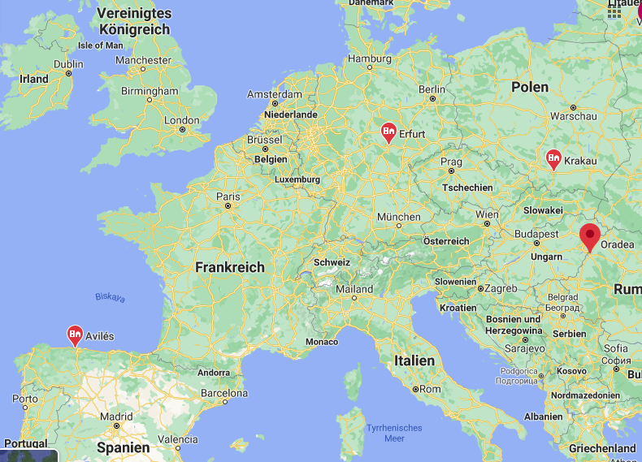

This FaTI project would have allowed us to meet in our different countries, spend time together, get to know each other, speak, work, play, eat and laugh together. But the Corona virus does not allow us to travel. So how to meet new people from other countries?

Well…. …. writing letters!

For more information please turn the page.

How to do it? Here are some ideas…

- Start with introducing your family. You can draw pictures that show your family. Or share photos of your family. As you and your children like
- You can share what the members of your family like very much; what do you like to eat, what do you like to do, what music do you like to listen to, do the children have a favourite book/toy/film, etc.
- Maybe you have some questions about the place where the other family lives. You can share pictures of your house, apartment, places you like or don’t like
- You can share with the others what you know about the other countries. You could ask questions. Check your own knowledge and maybe your prejudices.
- How is Corona affecting you? How is the situation in the other country?

These are just some ideas…

In all the four countries we have a contact person who you always can ask for support.
Spain: Vanessa Moreno vane@en-construccion.org
Romania: Cristi englishman_74@yahoo.com
Poland: Aleksandra Stinia stinia7@gmail.com
Germany: Petra Hildesheim/Christin Voigt hildesheim@naturfreunde-thueringen.de/christin.voigt@tool-pool.org

You can also ask those people for stamps.

And the best for the last!
Maybe we can meet in real life if the pandemic allows us to meet safely. We as project organiser hope to have one or two family exchanges in real life. You can be part of it!

We wish you a lot of fun with your pen pal families!

The FaTI team

